AI Urban Complaint & Maintenance Platform
Detailed Product Concept | Islamabad, Rawalpindi & Punjab
Proposed Product Name: UrbanFix
Tagline: Report a problem. Track the work. Make sure it gets resolved.
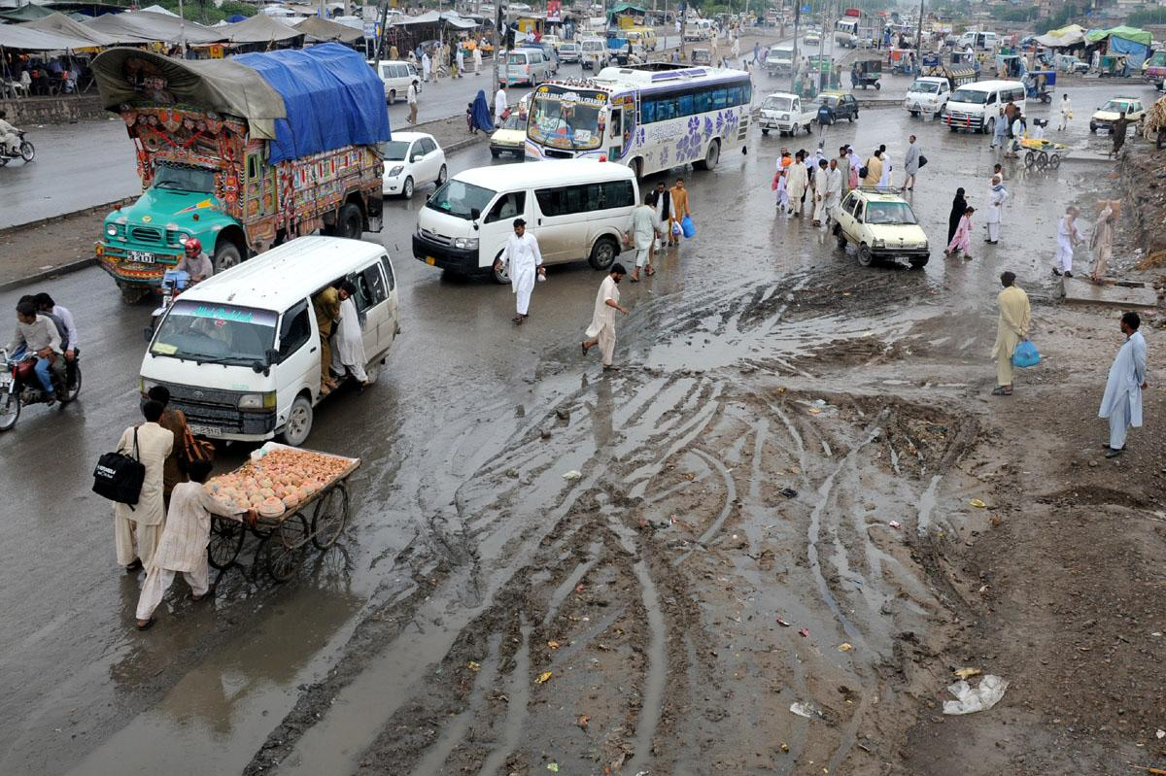
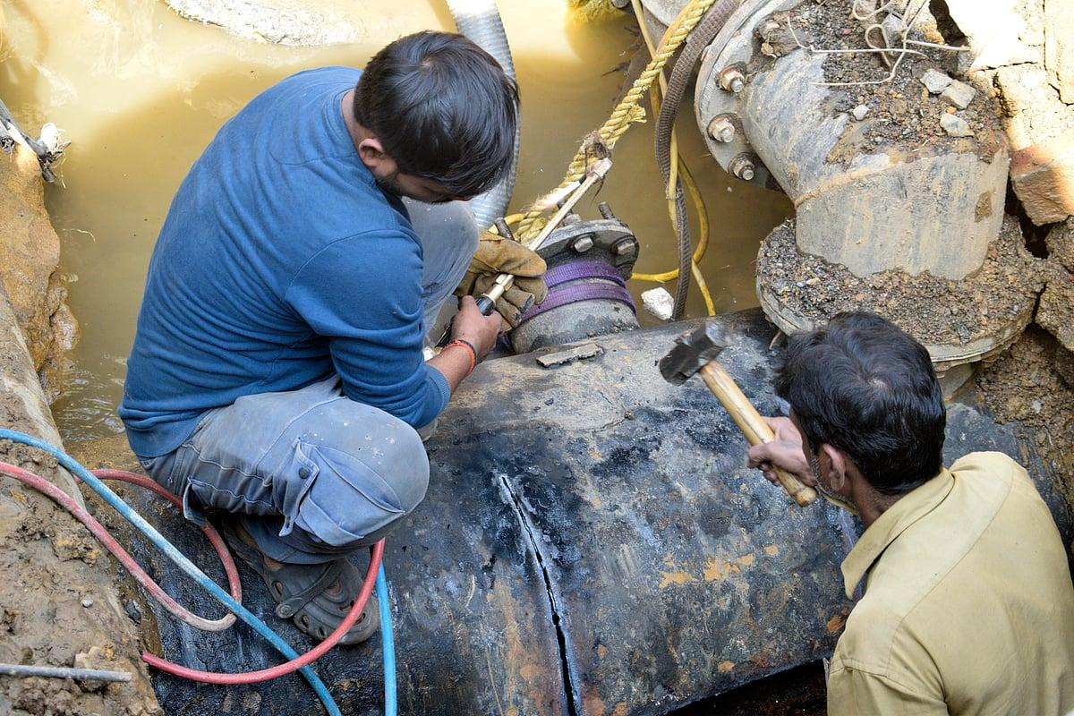
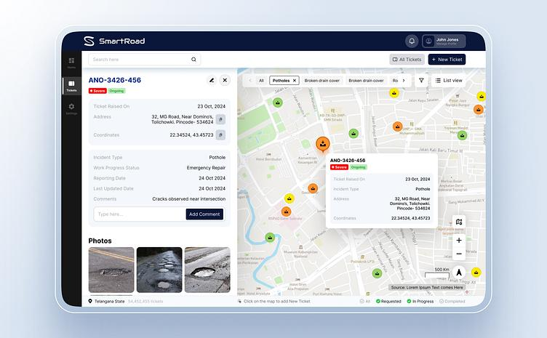
9
1. What is this product?
UrbanFix is an AI-powered software platform designed to help housing societies, apartment buildings, commercial communities, municipalities and maintenance companies manage everyday infrastructure and maintenance problems.
For example:
- A streetlight in a housing society stops working.
- A water supply pipe starts leaking.
- A road develops potholes.
- Garbage is not collected from a street.
- A sewerage line becomes blocked.
- A public park has damaged equipment.
- A resident reports an overflowing drain.
Today, such problems may be reported through telephone calls, WhatsApp groups, written applications or personal visits to the maintenance office.
The main problem is not just receiving a complaint. It is making sure that the complaint reaches the correct department, gets assigned to someone, is repaired and is properly verified before closure.
UrbanFix AI will manage this complete process.
Simple real-world example
A resident of a housing society in Rawalpindi notices that water is leaking from a pipe near their house.
They take a photograph and send a WhatsApp message:
"Street 12 mein house 45 ke samne pani ki pipe leak ho rahi hai. Subah se pani zaya ho raha hai."
The system will:
- Understand the complaint written in Roman Urdu.
- Identify that it relates to a water supply leak.
- Read the location provided by the resident.
- Create a complaint with a unique reference number.
- Suggest the responsible department: Water Maintenance.
- Assign the complaint according to approved management rules.
- Inform the resident that the complaint has been registered.
- Allow the maintenance team to upload repair photographs.
- Notify the resident when the work is reported complete.
- Ask for feedback or verification before final closure.
If the maintenance team does not respond within the configured time, the system can automatically escalate the complaint to the responsible supervisor.
2. Why could this product be useful in Pakistan?
Punjab has ongoing investment programmes for improving urban infrastructure, especially water supply, sewerage and sanitation. For example, Punjab Municipal Development Fund Company reported a $400 million investment programme covering 16 cities in February 2026.

PMDFC
However, the existence of infrastructure problems does not automatically mean there is demand for another complaint application.
Pakistan already has products such as the Pakistan Citizen Portal and Punjab's Aap Ki Baldia. Housing society applications also support complaint registration and tracking.

Punjab Police
+2
Therefore, our product should not be just another complaint registration app.
The opportunity worth investigating is a more complete maintenance management system that uses AI to reduce the work of maintenance departments and improve actual service delivery.
The distinction:
Traditional complaint software | Proposed UrbanFix AI
Resident manually selects complaint category | AI suggests category from text, voice or photo
Admin manually forwards complaint | System recommends department and team
Each complaint is handled separately | AI identifies possible duplicates and related incidents
Complaints appear as a list | Complaints also appear on maps and area-based dashboards
Workers manually report completion | System organizes before/after evidence for review
Management sees total complaints | Management also sees recurring defects, delays and maintenance patterns
Maintenance is mostly reactive | Later releases may help predict maintenance needs
These are proposed differences, not claims that every existing competitor lacks these capabilities.
3. Who will use this product?
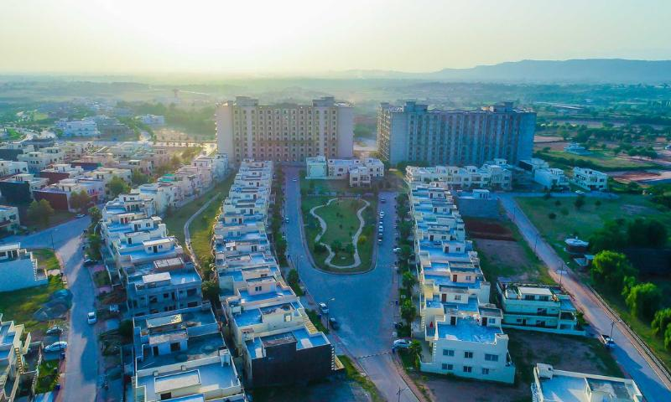
1. Housing societies
Examples include private residential societies in Islamabad, Rawalpindi, Lahore and other Punjab cities.
Management needs to handle streetlights, roads, water supply, sewerage, parks and common-area maintenance.
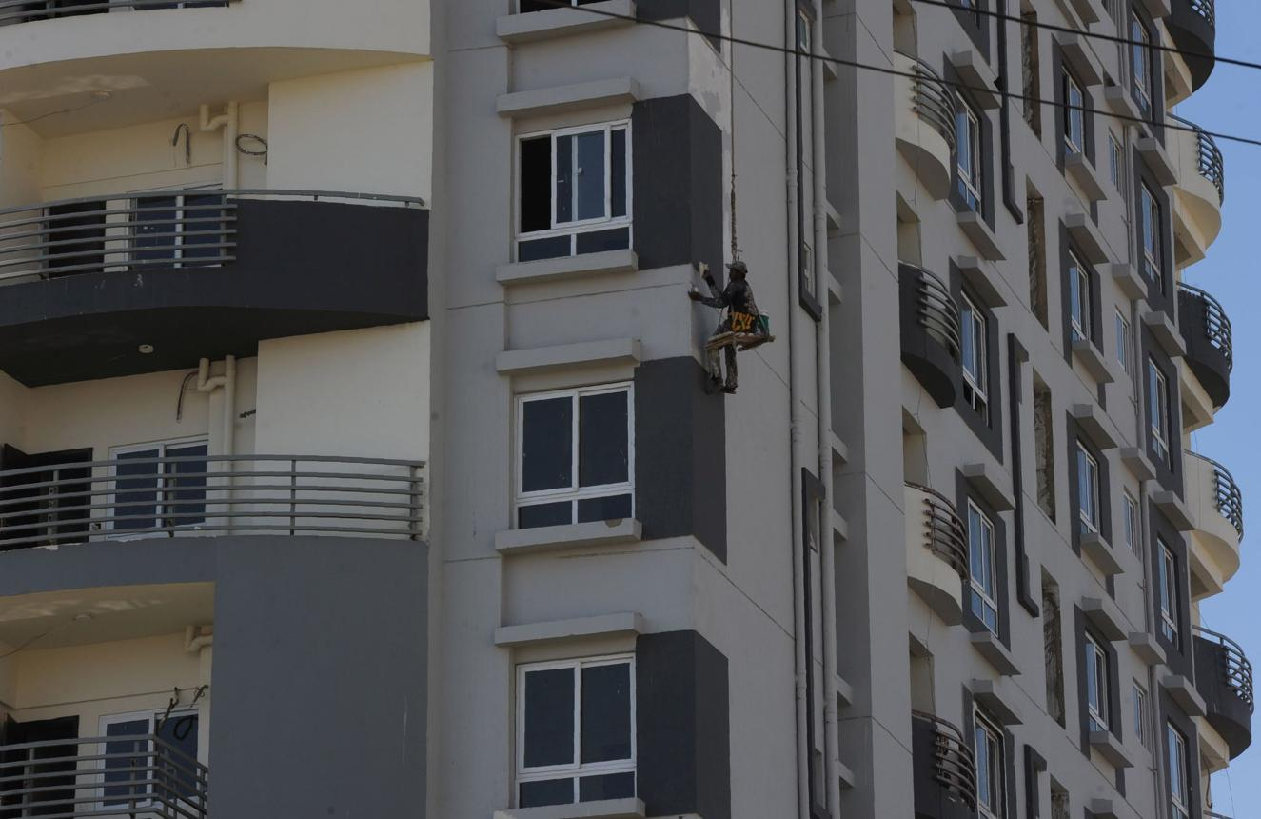
2. Apartments and commercial buildings
Property managers deal with elevators, plumbing, electricity, common areas, parking and building maintenance.
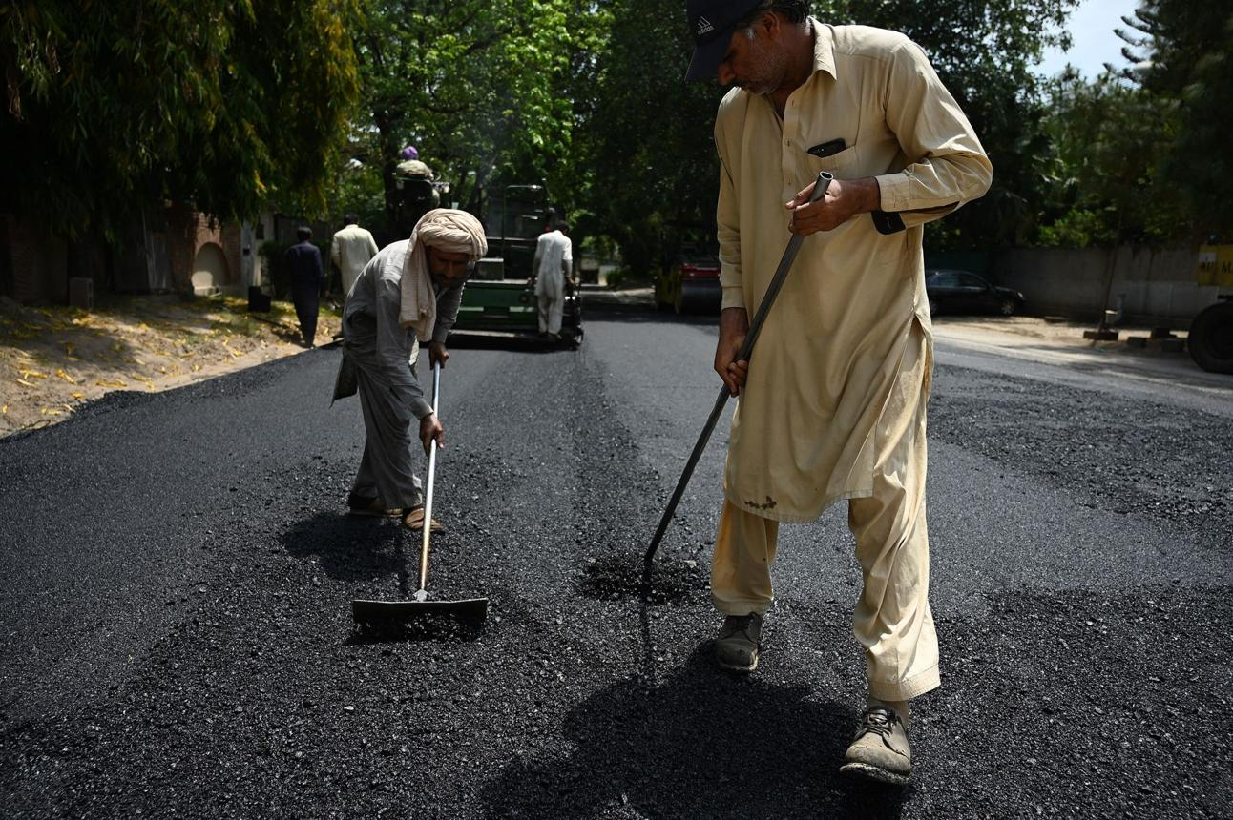
3. Municipal and local government organizations
Relevant departments may manage roads, drains, public lights, parks, sanitation and other civic infrastructure. Government procurement and integration requirements would need separate assessment.
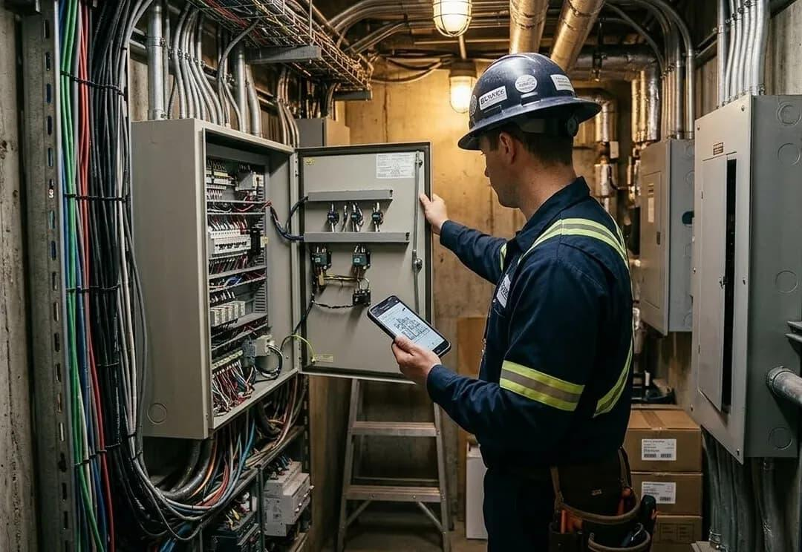
4. Facility management companies
Businesses providing maintenance services to multiple buildings could use the system for job assignment, technician tracking and customer reporting.
My preferred initial customer: Private housing societies and facility-management companies. They are more practical customers for an early pilot because the scope of responsibility and decision-making authority can be clearly defined.
4. Main product features explained with examples
Feature 1 — AI Complaint Registration
Residents should be able to submit complaints without filling out lengthy forms.
Supported channels could include:
- WhatsApp text messages.
- Photographs.
- Urdu and English voice notes.
- Web application.
- Mobile-friendly complaint form.
- Manual registration by society office staff.
Example
A resident writes:
"Sector B main street light kharab hai, please fix."
AI identifies:
Field | Value
Complaint category | Streetlight
Problem | Light not working
Location | Sector B — exact pole/location to be confirmed
Reported by | Registered resident
Status | New
Department | Electrical Maintenance
Priority | To be assessed
If the location is incomplete, the system asks for the street number or a map pin.
The application generates a complaint reference such as UF-2026-00125.
AI benefit: Residents do not need to understand how the society's departments or complaint categories are organized.
Feature 2 — AI Photo Understanding
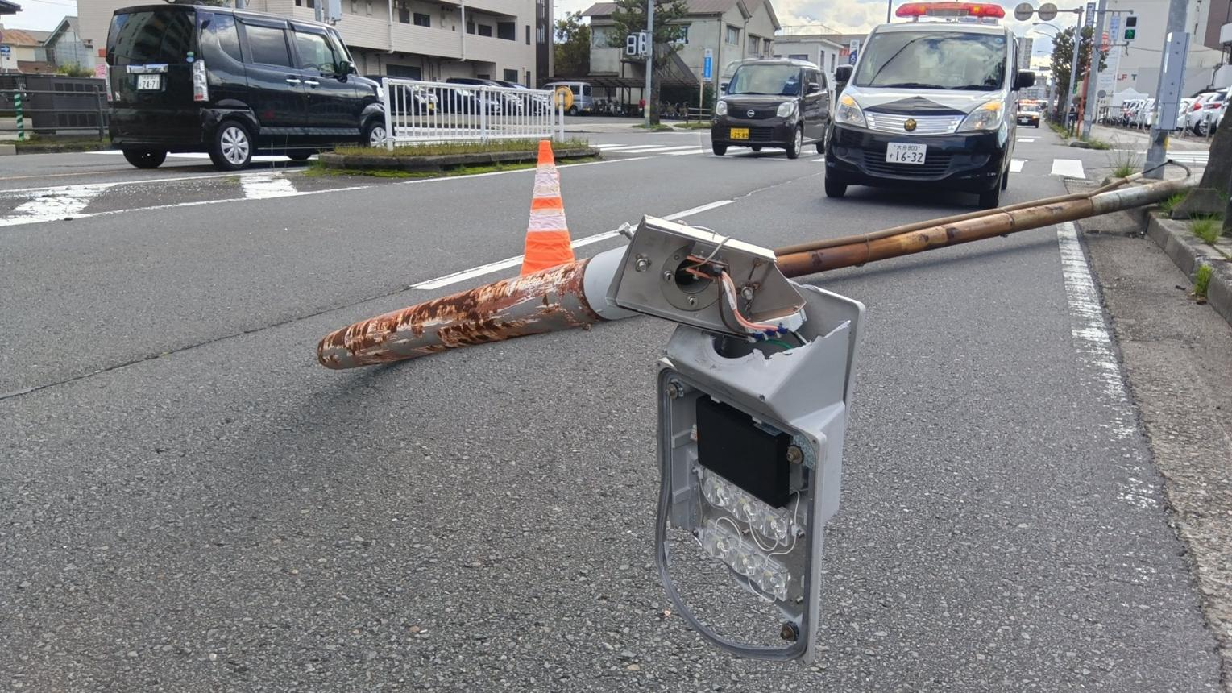
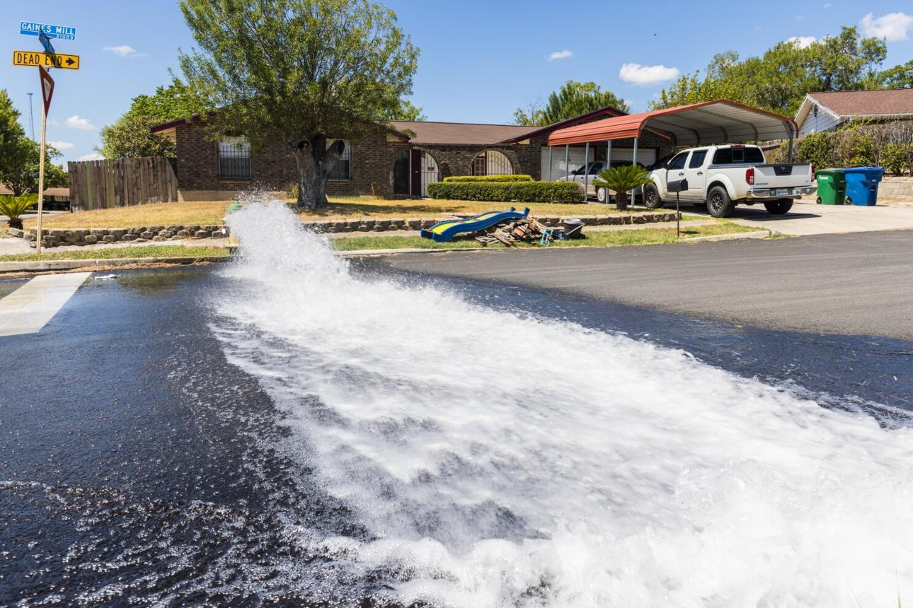
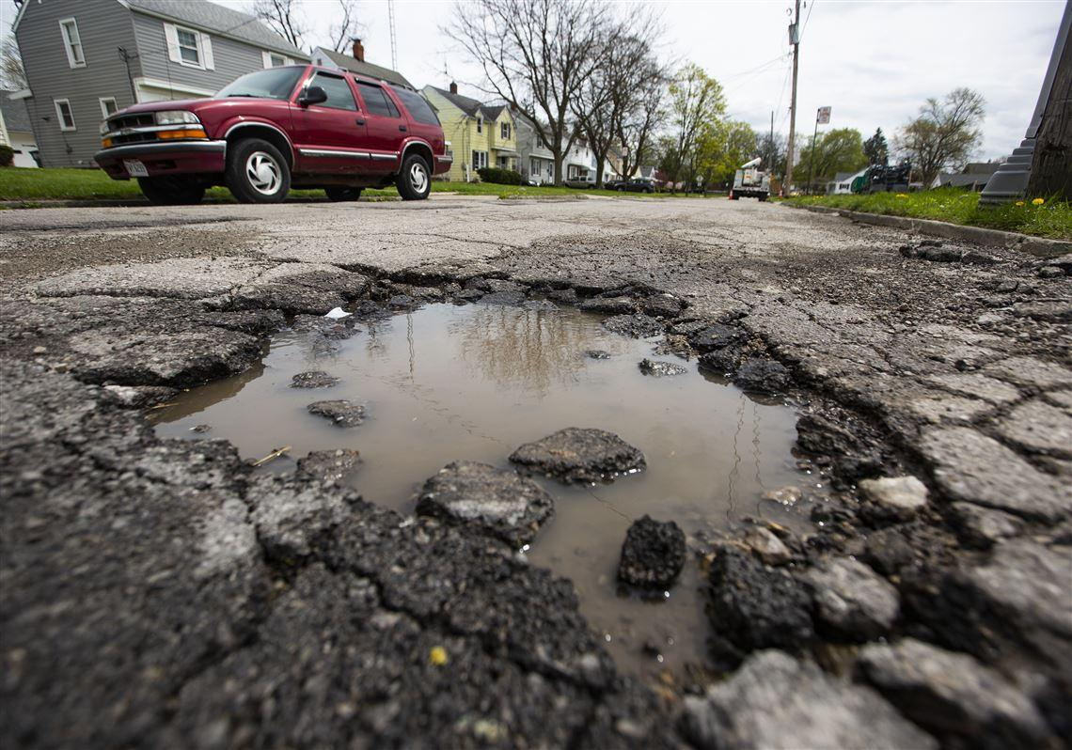
Residents may not be able to explain technical problems properly, but they can upload photographs.
The AI can inspect a photograph and suggest what it might show.
Example: A resident uploads a photograph showing water accumulating around a damaged pipe.
AI might generate:
"Possible water supply leakage. Visible standing water near a pipe connection. Requires maintenance inspection."
The system should ask for missing information and let the maintenance team confirm the problem.
Developer requirements:
- Image upload and storage.
- Image-quality and file-size checks.
- AI image analysis.
- Suggested issue category.
- Human correction.
- Original image attached to complaint.
The AI must not claim to have detected underground damage, electrical safety or a specific fault that cannot be verified from the photograph.
Feature 3 — Automatic Complaint Routing
Different problems belong to different teams.
For example:
Complaint | Suggested department
Water pipeline leakage | Water Supply
Streetlight not working | Electrical Maintenance
Broken road | Roads/Civil Works
Blocked sewerage line | Sewerage
Garbage collection issue | Sanitation
Damaged playground equipment | Parks Maintenance
Elevator breakdown | Building Maintenance
The administrator should configure the departments and rules for each customer organization.
Example: If a complaint is registered as a streetlight issue, the system recommends the Electrical Maintenance team.
A simple complaint can be routed automatically if the relevant department and location are clear and the customer has enabled the rule. Uncertain or sensitive assignments go to a supervisor.
AI benefit: Reduces time spent reading complaints and forwarding them manually.
Feature 4 — Maintenance Job Assignment
Receiving a complaint is only the first step. The system should turn an approved complaint into actual work.
Example
A water leak complaint is assigned to a supervisor, who creates a maintenance task.
Maintenance Job #125
Assigned
Problem
Water Pipe Leakage
Location
Street 12, Sector B
Assigned team
Water Maintenance
Priority
High — Supervisor confirmed
Task: Inspect the reported leakage, identify the problem, repair if authorized and upload completion evidence.
Illustrative maintenance assignment.
The assigned worker should be able to see the job, acknowledge it, update progress, add notes and upload photographs.
This creates a clear chain from complaint registration to completed work.
Feature 5 — Complaint Status and Tracking
Residents should be able to check complaint progress using a reference number, verified account or supported WhatsApp workflow.
Proposed complaint lifecycle:
1
New
Complaint received
2
Under Review
Details and responsibility being checked
3
Assigned
Maintenance team selected
4
In Progress
Work started
5
Resolved — Pending Verification
Team reports work completed
6
Closed
Completion verified or closed under approved policy
The workflow should also support reopening, rejection with a reason, and cases where a team cannot complete the task.
Feature 6 — Before-and-After Repair Verification
This is an important opportunity for product differentiation.
Example:
A resident submits a photograph of a damaged streetlight.
After repairing it, the maintenance worker uploads another photograph.
The AI can compare the original evidence and the completion image and highlight whether the images appear to show the same location or visible issue.
The supervisor reviews the evidence before closure.
Important limitation: A photograph cannot always prove a fault was fixed. For example, a streetlight photographed in daylight may not show whether it works, and a water pipeline may still leak underground.
Therefore, the system should combine photographic evidence with technician checks, supervisor approval and optional resident confirmation.
Feature 7 — Duplicate Complaint Detection
Sometimes several residents complain about the same problem.
Example
- Resident A reports a blocked drain on Street 10.
- Resident B reports standing sewerage water on Street 10.
- Resident C uploads a photograph of the same drain.
A traditional system might create three separate maintenance assignments.
UrbanFix AI could compare the issue category, location, time and evidence and suggest grouping these complaints under one incident.
Expected benefit: Reduce duplicated fieldwork while keeping all three residents updated.
The system should not automatically combine complaints when there is uncertainty that they refer to the same physical problem.
Feature 8 — AI Complaint Priority Suggestions
Not every complaint requires the same response time.
A damaged park bench and a fallen electrical cable have very different safety implications.
The AI may suggest priority based on complaint type, text and relevant rules.
Example | Suggested treatment
Minor damaged sign | Routine
Streetlight not working | Standard, adjusted for location and risk
Water pipeline leakage | Prompt review
Major sewerage overflow | Urgent inspection
Fallen live electrical wire | Immediate safety escalation
Critical distinction: AI can flag a potentially serious incident, but emergency routing must follow predefined safety rules and human oversight. A complaint app is not a substitute for calling emergency services.
Feature 9 — Location and GIS Mapping
GIS means Geographic Information System. In simple terms, it helps the system display and analyze maintenance problems on a map.
dribbble.com
Example
A society manager opens a map and sees:
- Several streetlight complaints along one road.
- Repeated water leak complaints around one pipeline.
- Frequent drainage problems near a particular intersection.
The system can show complaint density, maintenance status and asset locations.
Developer requirements:
- Map integration.
- Complaint coordinates or verified addresses.
- Location search.
- Area/sector filters.
- Complaint markers.
- Department-based layers.
- Area-wise reports.
Mapping gives management a geographical view instead of relying only on complaint lists.
Feature 10 — Maintenance Time Monitoring and Escalation
Each complaint category may have a target response or resolution time.
Example:
An approved rule states that serious water leakage complaints should receive initial staff attention within one hour.
If no one acknowledges the complaint within that period, the system notifies a supervisor.
Possible escalation rules:
- Task not assigned.
- Worker has not accepted task.
- Target date passed.
- Work marked complete without required evidence.
- Resident disputes completion.
These rules should be configurable for each organization.
AI can help summarize overdue work, but the escalation deadlines themselves should be enforced by ordinary application logic.
Feature 11 — Maintenance Materials and Cost Tracking
The system can record resources used to complete a job.
Example
Repairing a water connection required:
- Two workers.
- One replacement fitting.
- Pipe material.
- Transport.
- Three hours of work.
The maintenance supervisor enters the actual materials and costs.
Management can later see how much was spent on repeated repairs to the same asset.
AI opportunity: Highlight unusually frequent repairs or maintenance expense trends. This feature becomes more useful once sufficient records have been collected.
Feature 12 — Management Dashboard and AI Insights
UrbanFix AI — Management Overview
Sample Data
Total Complaints
248
Open
41
In Progress
29
Resolved
178
Complaints by department
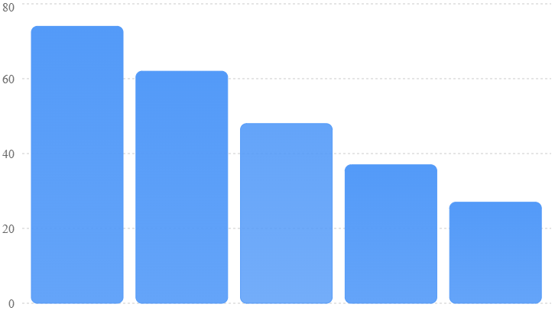
All figures are illustrative, to demonstrate a possible management interface.
Managers should be able to answer questions such as:
- Which sector has the most unresolved complaints?
- Which maintenance team has the most overdue assignments?
- Are water leakage complaints increasing?
- Which streetlights have been repaired repeatedly?
- What was the average time to complete complaints this month?
- Which complaints were reopened after closure?
The AI could generate plain-language summaries, for example:
"Water-related complaints increased in Sector C during the selected period. Most of the repeat incidents are around Streets 8–12. Management may want to inspect the shared water supply infrastructure."
This is where UrbanFix AI can become more valuable than a basic ticketing system.
5. Recommended development scope
I recommend two initial releases rather than building every advanced feature immediately.
Release 1 — Smart Complaint & Maintenance Management
Goal: Create a complete working application that receives complaints, manages repair assignments and records verified resolutions.
Feature | What developers should deliver
Organization management | Register housing societies, buildings and maintenance organizations
Resident/complainant management | Registration, identification and authorized complaint tracking
Complaint registration | Text, images and manual entry
WhatsApp integration | Submit and check complaints through supported messaging workflows
Urdu/Roman Urdu AI | Understand and classify complaint descriptions
Photo interpretation | Suggest the likely visible problem from uploaded pictures
Department routing | Map complaints to configured departments
Maintenance task assignment | Assign work to employees and teams
Status tracking | Track progress from registration through closure
Duplicate detection | Suggest complaints that may relate to the same incident
Before/after evidence | Upload and review repair photographs
Priority rules | Flag potentially urgent complaints
Notifications | Complaint receipt and important status updates
Management dashboard | Counts, filters, department workloads and overdue tasks
Access and audit controls | Protect data and record important actions
Example Release 1 demonstration: A resident reports a broken streetlight through WhatsApp. The system creates a complaint, routes it to the correct team, allows a technician to update progress and enables the supervisor to verify completion.
Release 2 — AI Maintenance Intelligence & GIS
Goal: Help management plan maintenance more intelligently, detect recurring problems and improve field operations.
Feature | What developers should deliver
GIS maps | View complaints, locations and maintenance assets on maps
Complaint hotspots | Identify concentrations of recurring incidents
Asset management | Maintain records of streetlights, pipelines, pumps and other assets
Repeat-fault analysis | Identify assets requiring repeated repair
Advanced image comparison | Help reviewers compare before/after evidence
Field staff application | Mobile-friendly task handling and field updates
Maintenance cost tracking | Record material costs, labor and repair spending
AI maintenance insights | Analyze delays, failures and recurring problems
Preventive maintenance | Schedule routine inspection and maintenance
Area performance reports | Compare sectors, teams and resolution times
Multi-site organization management | Support multiple properties under one maintenance organization
Workload planning | Recommend work allocation using available operational data
Future enhancements beyond Release 2: Drone inspections, automatic pothole detection from vehicle video, sensor-based leak detection and advanced predictive maintenance. These should only be considered after real-world adoption and sufficient data collection.
6. Suggested technology stack
The team does not need to develop its own AI model initially.
Technology | Purpose | Alternative
React + TypeScript | Build management and staff web interfaces | Angular
ASP.NET Core | Handle complaints, tasks, users and business rules | Node.js/NestJS
SQL Server or PostgreSQL | Store complaints, locations, tasks and history | Either supported relational database
Python + FastAPI | Process AI text, photographs and analysis | AI functions within .NET
Vision-capable AI models | Suggest issue categories from images | Specialized computer vision models
Language AI model | Understand Urdu, English and Roman Urdu | Fine-tuned multilingual classifier
Official WhatsApp Business Platform | Resident communications | Web form and app-based communication
Leaflet + OpenStreetMap | Display geographic complaint locations | MapLibre
PostGIS | Analyze locations and nearby incidents | SQL Server spatial functions
SignalR | Update management and worker dashboards | WebSockets
Background task processing | Schedule notifications and escalations | Hangfire, Quartz
AI versus conventional software
Not every feature needs AI.
Use AI for | Use normal application logic for
Understanding complaint descriptions | Complaint number generation
Suggesting categories | User permissions
Interpreting photographs | Assignment rules
Finding similar complaints | Status updates
Summarizing maintenance histories | Deadline calculation
Identifying complaint patterns | Audit logging
Recommending repair priorities | Saving maintenance records
This separation keeps the application more reliable and reduces unnecessary AI operating costs.
7. Existing products and competition in Pakistan
Before development, it is important to understand that complaint management software already exists. The main business challenge will be proving why customers should buy a more advanced AI-based solution.
Existing solution | What it currently offers | Opportunity to investigate
Hamari Society | Society complaints, visitor management, billing and community operations | More specialized AI maintenance analysis
NPF Maintenance | Resident requests, photographs and complaint tracking | Advanced fault patterns and asset management
Manzhil | WhatsApp-based society communication and complaints | More sophisticated field-work and GIS workflows
Aap Ki Baldia | Municipal complaint services | Institutional maintenance operations and approved integration
These products demonstrate that digital complaint registration is already a recognized category. Their public feature descriptions alone are not enough to conclude which advanced AI capabilities they do or do not have.

Apps on Google Play
+3
Where UrbanFix AI could be different
Instead of competing as a general housing society management app, position UrbanFix AI as a maintenance operations and infrastructure intelligence platform.
Its selling point should be the complete journey from reporting a problem to verifying repair, understanding repeated failures and planning maintenance more effectively.
8. Business and revenue model
Potential paying customers include private housing societies, apartment management companies, commercial building operators and facility-management companies.
An illustrative pricing hypothesis to validate through customer interviews:
Customer segment | Possible monthly subscription
Small apartment/community | PKR 5,000–15,000
Medium housing society | PKR 15,000–40,000
Large housing society | PKR 40,000–100,000+
Multi-property facility-management company | Custom
These are proposed price ranges for testing, not researched selling prices or verified willingness to pay. Implementation, messaging, hosting and AI usage fees would also need consideration.
9. Recommended first proof of concept
POC Name: AI Complaint Registration & Maintenance Tracking
Develop a small working website supporting one housing society, four maintenance departments and a realistic test set of complaints.
The POC should demonstrate the entire process:
Resident submits complaint with text/photo
AI suggests category, location and department
Supervisor assigns maintenance job
Technician completes work and uploads evidence
Supervisor verifies and closes complaint
Management reviews status and performance
For initial testing, use examples such as water leakage, damaged roads, streetlights and sewerage complaints. Include Urdu, Roman Urdu and English descriptions.
A successful POC should prove that the complete complaint-to-repair workflow works, that AI suggestions can be corrected by staff, and that all changes remain traceable.
10. Final product recommendation
I would recommend the following market entry strategy:
Start with private housing societies in Rawalpindi and Islamabad, rather than approaching government authorities immediately.
Interview society administrators, maintenance supervisors, technicians and residents to understand their existing complaint-handling process.
Identify whether their main problem is complaint registration, tracking, staff accountability, recurring maintenance failures, reporting or something else.
Build Release 1 around the most costly problem actually identified through those interviews.
Then use Release 2 to introduce GIS, asset histories and AI-driven maintenance intelligence.
The most important commercial principle: A complaint app alone is unlikely to be sufficiently differentiated. A product that helps management reduce recurring breakdowns, avoid repeated field visits, improve staff accountability and control maintenance costs has a stronger potential business case.
UrbanFix AI should therefore be marketed not simply as an AI complaint application, but as an AI-powered Maintenance Management and Urban Infrastructure Intelligence Platform.

